

VIVEKANANDHA
COLLEGE OF ENGINEERING FOR WOMEN
(AUTONOMOUS)

Approved by AICTE, New Delhi │ Affiliated to Anna University, Chennai
NAAC Accredited – A++ Grade │ NBA Accredited – CSE, EEE, ECE, IT & Biotech
ISO 9001:2015 Certified

TIRUCHENGODE - 637 205. NAMAKKAL DIST.

TITLE
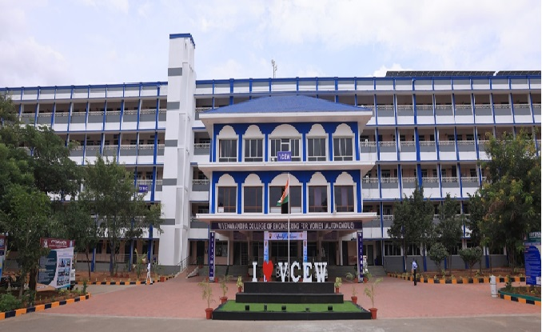

Organized by

DEPARTMENT

DATE

VIVEKANANDHA
COLLEGE OF ENGINEERING FOR WOMEN
(AUTONOMOUS)

Approved by AICTE, New Delhi │ Affiliated to Anna University, Chennai
NAAC Accredited – A++ Grade │ NBA Accredited – CSE, EEE, ECE, IT & Biotech
ISO 9001:2015 Certified

TIRUCHENGODE - 637 205. NAMAKKAL DIST.

TITLE

REPORT

Organized by

DEPARTMENT

DATE

VIVEKANANDHA
COLLEGE OF ENGINEERING FOR WOMEN
(AUTONOMOUS)

Approved by AICTE, New Delhi │ Affiliated to Anna University, Chennai
NAAC Accredited – A++ Grade │ NBA Accredited – CSE, EEE, ECE, IT & Biotech
ISO 9001:2015 Certified

TIRUCHENGODE - 637 205. NAMAKKAL DIST.

DEPARTMENT

TITLE

Date:

INDEX

S.No. | Particulars | Page No.
1 | Report
2 | Approval Letter
3 | Circular
4 | Agenda
5 | Chief Guest Profile
6 | Presentation Details
7 | Photos
8 | Attendance
9 | Feedback
10 | Certificate
11 | Expenditure Details

HoD Director IQAC PRINCIPAL

Report

REPORT

APPROVAL LETTER

CIRCULAR

AGENDA

Chief Guest PRofile

Presentation details

PHOTOS

ATTENDANCE

FEEDBACK

Certificate

Expenditure Details

Sample report

VIVEKANANDHA
COLLEGE OF ENGINEERING FOR WOMEN
(AUTONOMOUS)

Approved by AICTE, New Delhi │ Affiliated to Anna University, Chennai
NAAC Accredited – A++ Grade │ NBA Accredited – CSE, EEE, ECE, IT & Biotech
ISO 9001:2015 Certified

TIRUCHENGODE - 637 205. NAMAKKAL DIST.

FDP on
“Outcome Based Education (OBE)-
Implementation Strategies”

Organized by
INTERNAL QUALITY ASSURANCE CELL

23rd June 2025

VIVEKANANDHA
COLLEGE OF ENGINEERING FOR WOMEN
(AUTONOMOUS)

Approved by AICTE, New Delhi │ Affiliated to Anna University, Chennai
NAAC Accredited – A++ Grade │ NBA Accredited – CSE, EEE, ECE, IT & Biotech
ISO 9001:2015 Certified

TIRUCHENGODE - 637 205. NAMAKKAL DIST.

FDP on
“Outcome Based Education (OBE)-
Implementation Strategies”

REPORT

Organized by

INTERNAL QUALITY ASSURANCE CELL

23rd June 2025

VIVEKANANDHA
COLLEGE OF ENGINEERING FOR WOMEN
(AUTONOMOUS)

Approved by AICTE, New Delhi │ Affiliated to Anna University, Chennai
NAAC Accredited – A++ Grade │ NBA Accredited – CSE, EEE, ECE, IT & Biotech
ISO 9001:2015 Certified

TIRUCHENGODE - 637 205. NAMAKKAL DIST.

INTERNAL QUALITY ASSURANCE CELL

FDP on “Outcome Based Education (OBE)-
Implementation Strategies”

Date: 23.06.2025

INDEX

S.No. | Particulars | Page No.
1 | Report | 1
2 | Approval Letter | 2
3 | Circular | 3
4 | Agenda | 4
5 | Chief Guest Profile | 5
6 | Presentation Details | 35
7 | Photos | 74
8 | Attendance | 80
9 | Feedback | 85
10 | Certificate | 95
11 | Expenditure Details | 96

Director IQAC PRINCIPAL

Report

REPORT
Vivekanandha College of Engineering for Women (VCEW) organized a Faculty Development Programme (FDP) on “Outcome Based Education – Implementation Strategies” on 23rd June 2025 at the Main Seminar Hall. The FDP aimed to strengthen the understanding and practical application of Outcome Based Education (OBE) among faculty members, in alignment with national quality assurance frameworks.
The programme commenced with a Welcome Address by Prof. K.C.K.Vijayakumar, Principal, VCEW. The session was Presided Over by Prof.Dr.M.Karunanithi, Chairman and Secretary, Vivekanandha Educational Institutions.
The event was graced by the presence of Prof.Dr.S.Kuppuswami, Executive Director, and Dr.R.Balagurunathan, Director-Research, who felicitated the chief guest and shared insightful remarks on the critical role of OBE in enhancing academic quality and global competitiveness in higher education.
The technical session was delivered by Dr.Kanamani Buddhi, Professor, Department of Telecommunication Engineering, B.M.S. Engineering College, Bengaluru. An expert in the field, Dr.Kanmani Buddhi provided a detailed overview of OBE principles, including curriculum design, mapping of Course Outcomes (COs) to Program Outcomes (POs), attainment measurement, and best practices for continuous improvement. The interactive session included practical strategies and case-based discussions, which helped faculty relate concepts to institutional implementation.
A total of 97 faculty members from various Vivekanandha Educational Institutions actively participated in the programme and gained practical insights into implementing OBE effectively in their respective departments.
The FDP concluded with a Vote of Thanks by Dr.M.Murugan, Director- IQAC, who expressed gratitude to the resource person, dignitaries, organizing team, and all participants for contributing to the success of the programme.

APPROVAL LETTER

CIRCULAR

AGENDA

Chief Guest PRofile

Presentation details

PHOTOS

ATTENDANCE

FEEDBACK

Certificate

Expenditure Details

